Brief Project Description Project Title: ERP System for Institutes
ERP system is major tool which control all functionality of the institute, enterprise resource planning software also used to control the business & student management of the institution. ERP system used in higher education system to control the business overflow and manage the database system of the entire university student throughout the graduate degree. ERP system manage by the IMS system, the information management system control all IT networking of the institute by installing centralized domain server including ERP system. Since the MIS system contains only student basic detail so this research identify the research gap and address them merging the MIS system to ERP system with new invention software. The aim of this project is going to deploy the ERP system solution for academics, since the previous ERP system does not perform very well, due to research gap exist in the MIS (Management information system and enterprise resource planning software) the aim of this research to develop python & MYSQL software product which combine both MIS and ERP in one platform. (Ram, M., 2021) since the ERP consultation was challenging part, the problem exist on ERP system by making decision making policy, ERP project is risk prone due to software complexity. ERP vendor and selection criteria is important selection for selecting consultation & rank criteria. In context of complex fuzzy logic based system which proposed to solve the ERP complexity.
Current ERP security policies not meet the system requirement so there is need to improve the security policies. The current business models which designed to propose on the basis of academic & education institute student requirements. ERP privacy protection planned according to the student and academician requirement.
Staff Consulted

(Laganaro, M., 2018) ERP evidence of distinct processes fundamental semantic facilitation interference in the world population. Typical result of ERP solution has been identified by experiencing the previous ERP solution software, various programming mitigation has been identified various database modelling prototype does not match the business logic of ERP system the entire database planning needs to revisit them to modified them according to the educational need. (T.S., 2017) it was suggested by various researcher the python based programing solution approach very good because of lightweight feature of internal library of python beside this the MySQL database implemented by deploying the forward engineering concept which meet the exact business requirement of the entire educational institute. Research suggest that the python based approach recognize as well done ERP approach for deploying complex business logic, since the python library perform TIS and RETIS simulation (Oken, B., 2021) since the brain computer software solution interface exist in the python programming to model the brain structure as well by deploying deep learning based programing, since the python is emerging technology programming language which interface the solution of complex problem, the current research going to develop data acquisition, data query, student management, faculty management, schools program management and modelling of various business solution.

Client
This research findings proposed on all latest python programing interfaces which used to mitigate all the previous programing such as ASP.net, C# and Java. Since the python is library based modelling programming which emerge all of the latest research into one platform and solve the various complex operation. (K.S., 2013) the comparison based studies by exploring various exploratory research finding which suggest python based solution best solution to design the ERP modelling. Since the ERP software was very complex to design to meet the need of expectations and some largest and most sophisticated organization in the world, the research suggest that the non-profit educational institute executes with better finance and decision policy to make education more organize and advance by deploying the complex ERP solution. The higher rating educational institute in advance countries uses complex ERP software to facilitate the online admission system and online fee submission based system which backend connected with the cloud computing server proposed on Amazon Cloud and Google cloud computing server. Since the cloud computing provides off line server virtualization concept which facilitate them all of the students of abroad country to takes admission on virtual distance and make them unique according to the better planning of ERP software.

Resources

Tool:
- Python
- MYSQL

Risks
Risk factor is always challenging issues for the deploying of ERP based solution. ERP software now connected with online cloud computing server to support 24/7 based queries. Since the development of small and medium enterprises system failure due to the server point of failure connection in the development of ERP solution. (Mininno, V., 2007) risk management in the development of ERP based system by reviewing the exploratory research finding. ERP system always considered very complex due to increase of business requirement and user requirement. Educational institute facing high risk due to failure of ERP software by change of studies scheme on every year, so the programming changing needs to change and revisit the overall ERP based system.

Justification

Analysis identify the drawback of previous ERP system and fulfil the research gap with new technology. The latest ERP system now available on cloud computing based enterprise solution to market the educational requirement manage the student, manage the entire faculty database requirement and also manage the student online examination system with best result compilation method based on the secure environment. So this project going to develop python based desktop ERP application which are going to merge the MIS system and university ERP system in one platform.

Since the old fashioned ERP solution does not provide the correct accuracy to meet the business requirement of the educational institute so the research finding suggest that the current ERP software centralized and cloud computing based, but there is need to solve the some risk factor by deploying the ERP software at their end to check the education progress and student progress by deploying server role at the entire educational backbone. So the current situation suggested with python based solution which enable the research to design better ERP solution to low the failure of ERP risk factor about less than 5%. Since in the past the failure of ERP software rate was very high due to non-technology deployment with nonprofessional programming interface. Amazon and Google ERP cloud system is one of the best system in the year 2022. Since Microsoft azure and Oracle ERP does not meet the requirement of educational need. The research sampling strategy is purposeful to design the ERP project by deploying snow ball sampling principle. Performed web survey and collecting dataset of research professor which their aim of better education ERP solution and more 150 educational institution comparison based system and design better ERP solution in replacement of previous ERP tool. Data analysis method proposed to evaluate the research data from 2000 to 2021.

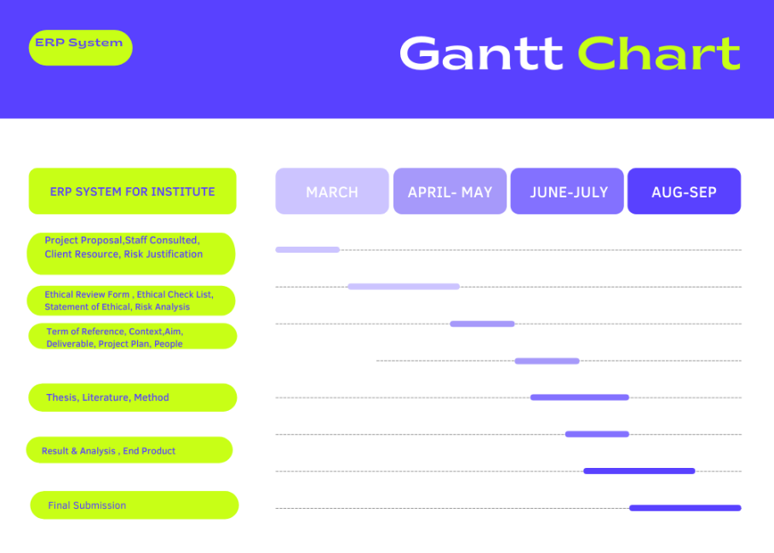
References
Kendle, A.S., Nagare, M.S., Patre, H.G., Zanwar, R.S., Kottawar, V.G. and Deskhmukh, P.B., 2021, May. TnP Vision: Automation and Analysis of Campus Placements in Colleges. In 2021 5th International Conference on Computer, Communication and Signal Processing (ICCCSP) (pp. 1-6). IEEE.
Remil, Y., Bendimerad, A., Mathonat, R., Chaleat, P. and Kaytoue, M., 2021, November. " What makes my queries slow?": Subgroup Discovery for SQL Workload Analysis. In 2021 36th IEEE/ACM International Conference on Automated Software Engineering (ASE) (pp. 642-652). IEEE.

